Name_______________________________________ English 2 CP/The Great Gatsby
Complete the following questions and statements.
1. What does Tom Buchanan do to Myrtle Wilson towards the end of the chapter? Did Myrtle have the right to say what she said? Why did Tom do what he did? What theme(s) does this incident bring up?

2. Use the Venn Diagram to compare and contrast the Valley of Ashes and its inhabitants with East Egg and its inhabitants. Then draw a conclusion(s) from the diagram and write these conclusions below the diagram.
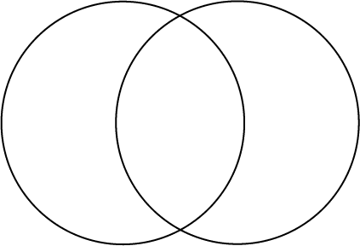

From this diagram I can conclude that…

3. What do/can the rich expect? What do/can the poor expect?
Use 2 characters to explore this theme and write down a quotation(s) that prove your point.

4. Symbolism is very important to the modern writer. Fitzgerald employs a multitude of symbols in this chapter to represent certain ideas/concepts/philosophies/cultural norms. Explain these images in terms of what they symbolize and why they are in the novel.
The eyes of Dr. T.J. Eckleburg

The dog

The “incessant clicking” of “innumerable pottery bracelets” jingling on Catherine & the furniture in the apartment

The picture of the gardens at Versailles

5. SOUND OFF – write anything here that isn’t on this worksheet that you want to discuss/question/investigate!!!

