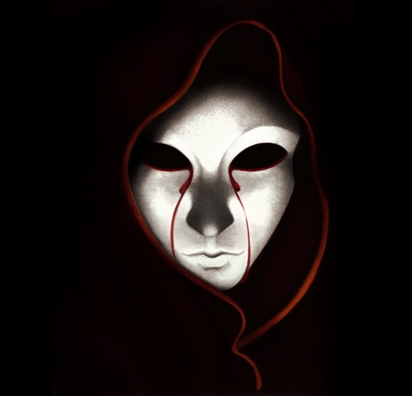
The Masque of the Red Death
Question the Movie Trailer. Contagion
What does this trailer imply about fear/death/prevention?

Essential Question(s)
If we can’t escape death, why do we try so darn hard to prevent its arrival?

Question the story. The Masque of the Red Death
“And Darkness and Decay and the Red Death held illimitable dominion over all.”
What does Poe imply about death?

Ok. So how does Poe say this in the frame of a gothic short story? Let’s check out Poe’s Philosophy of Composition.
1846 Essay by Poe offering his theory on how good writers write when they write well. He uses The Raven to highlight the important issues involved in writing well. Although Poe is categorized as part of the Romantic Movement, Dark Romantic to be specific, he offers a very classical and logical method to constructing his works. Some people look at his essay as a satire and a ploy for Poe to keep his readership.
- Length – all words should be short. "a distinct limit... to all works of literary art - the limit of a single sitting."

- Method – methodical and analytical, NOT spontaneous or intuitive.

- Unity of Effect (Single Effect) – start with the ending emotion you want to create. Single effect leads to tone, theme, setting, plot, characters, conflict GOTHIC STYLE.

Activity
Create a 1 page gothic style story using poe’s philosophy of composition. we will read these stories next class! muahahahahahaha
“the death, then, of a beautiful woman is, unquestionably, the most poetical topic in the world.”

